HTTP headers:

- Allows client and the server to pass additional information with the request or reponse
- They carry information about the client browser, the requested page, the server and more.

Response Headers: Headers with additional information about the response and a component of a network packet that is sent by the web server to a web browser or a client machine in reponse to a HTTP request.

Or simply put HTTP headers is used to control how the web browser should render a page blalbalbalbalba
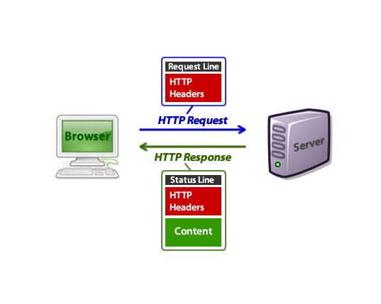

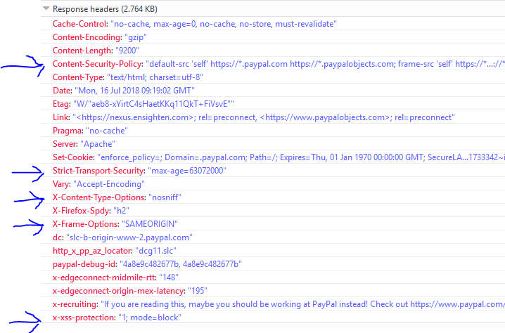

- X-Frame-Options – HTTP response header can be used to indicate whether or not a browser should be allowed to render a page in a <frame>, <iframe> or <object>.

The header, when set by website owner, declares its preferred framing policy: values of DENY, SAMEORIGIN, or ALLOW-FROM origin will prevent any framing, framing by external sites

Clickjacking is an attack that tricks a web user into clicking a button, a link or a picture, etc. that the web user didn’t intend to click, typically by overlaying the web page with a (typically transparent) iframe. The user thinks he is clicking the link on the legitimate page, but actually clicks an unseen overlaid link or button.

Directives for X-Frame-Options:

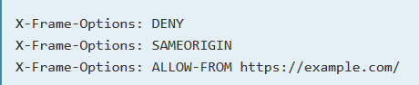

.

Implementing X-Frame on different site's configuration

Apache:

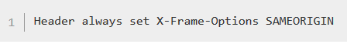

nginx:

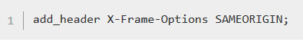

Microsoft IIS:

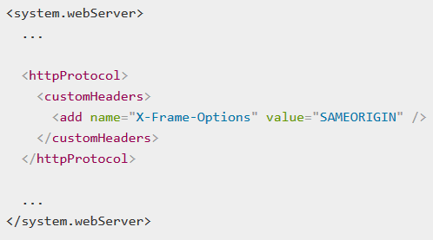

https://security.stackexchange.com/questions/167081/how-to-add-x-frame-options-header-to-a- simple-html-file

- Content-Security-Policy – added layer of security that helps to detect and mitigate certain types of attacks

A security standard introduced to help prevent XSS and other content injection attacks, it achieves this by restricting sources of content loaded by the user agent to those only allowed by site operator

To enable CSP, configure web server to return the Content-Security-Policy HTTP header

Using CSP: To configure CSP, just add the Content-Security-Policy HTTP header to a web page.

Implementing CSP: Define lists of allowed origins for the all of the type of resources that your site utilizes.

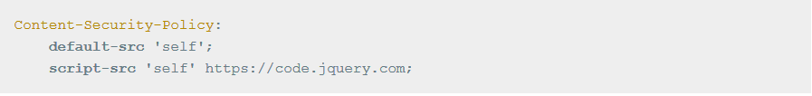
https://hacks.mozilla.org/2016/02/implementing-content-security-policy/
https://stackoverflow.com/questions/28715989/how-to-implement-content-security-policy

- X-XSS-Protection

- X-Content Type Options

- Strict-Transport-Security – response header that lets a website tell browsers that it should only access using HTTPS instead of HTTP

Inform web browsers how to handle its connection through a response header or HSTS forces
browsers or application to use HTTPS if its only available. Even if someone just types "www" or http://

HSTS addresses following threats:

- User bookmarks or manually types http://example.com and is subject to a man-in-the-middle attack

  - HSTS automatically redirects HTTP requests to HTTPS for the the target domain

- Web Application that is intended to be purely HTTPS inadvertently contains HTTP links or serves content over HTTP

  - HSTS automatically redirects HTTP requests to HTTPS for the target domain

- A man-in-the-middle attacker attempts to intercept traffic from a victim user using an invalid certificate and hopes the user will accept the bad certificate

  - HSTS will not allow a user to override the invalid certificate message

